TIME WARP – WITHOUT SPACE TRAVEL
John F. Ehlers

One of the most frustrating aspects of technical analysis is avoidance of whipsaw trades. When the moving averages are made smoother to avoid these whipsaws the lag produced by the smoothing often renders the signals to be ineffective. The dilemma is therefore how to strike a balance between the amount of smoothing that can be obtained and the amount of lag that can be tolerated. In this article, you will receive new tools to address the smoothing versus lag problem more effectively. In particular, you will learn about better smoothing filters, and a brand new, fast-acting RSI indicator.

A moving average is a simple concept involving sampled data. One averages the data over the last “N” samples, moves forward one sample and averages over the new set of “N” samples, and so on. Actually, of each new set of N samples, only the oldest sample is discarded and one new sample is added. In any event, the average is done over a fixed number of samples and moved forward one sample at a time. In this way the average “moves”. An engineer views the process differently. He sees the data moving down a fixed delay line that is tapped to get the output of each sample, and the tap outputs are added together to produce the moving average. This process is depicted in the schematic of Figure 1 for a 4 bar moving average. In Figure 1, the symbol Z⁻¹ means that there is one unit of delay. In the case of daily data, the delay would be one day. The filter response in terms of the Z Transform is:
H(z) = 1 + Z⁻¹ + Z⁻² + Z⁻³

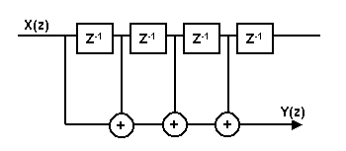
Figure 1. Schematic of a Moving Average

The equation for the moving average, in EasyLanguage format, is:
Filt = (Price + Price[1] + Price[2] + Price[3]) / 4;
That is, successively older data samples from the newest sample are averaged to attain the filtered output. The tapped delay line concept is favored by Engineers because more generalized FIR filters can be developed by changing the relative amplitudes of the samples. For example, if we wanted the middle two samples to have twice the weight as the newest sample and oldest sample in our 4 sample example, the schematic diagram would be as shown in Figure 2.

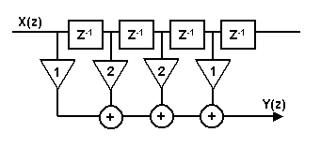
Figure 2. Schematic of a Four Element FIR Filter

The equation of the FIR filter, in EasyLanguage format, is:
Filt = (Price + 2*Price[1] + 2*Price[2] + Price[3]) / 6;
The multipliers on price are called the coefficients of the filter. Please note that the filter is always normalized to the sum of the coefficients. This normalization is done so that the output will be the same as the input if all the samples have the same value. In engineering terms, the DC gain is equal to unity.

The best way to compare the outputs of a moving average and a FIR filter is by examining their frequency response. Since we are dealing with sampled data, the highest frequency that we can consider has two samples per cycle. This is called the Nyquist frequency. So, on daily data, a two bar cycle is at the Nyquist frequency, which is a normalized frequency of 1. A cycle having a four bar period has a normalized frequency of 0.5. The general relationship between the cycle period and normalized frequency is:
Frequency = 2 / Period
With this relationship in mind, the frequency response of the four bar moving average is shown in Figure 3. The amplitude is in decibels, a logarithmic scale where 0 is the largest unattenuated amplitude. Since this occurs at the left of the frequency range, we know the zero frequency gain of the filter is zero. Note the 2 bar cycle and 4 bar cycle are exactly notched out by the moving average. The filtering between the 2 bar and 4 bar cycle is down only a little more than 10 dB from zero gain.

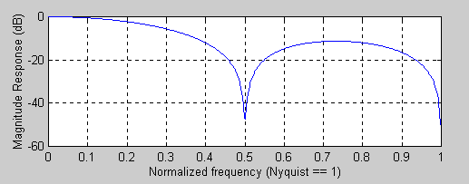
Figure 3. Four Bar Moving Average Frequency Response

The frequency response of the FIR filter of Figure 2 is shown in Figure 4. Manipulating the coefficients has improved the filtering to be greater than 20 dB. However, the frequency notch has moved up to be at a 3 bar cycle. That is, the bandwidth of the filter is wider than the bandwidth of the moving average. A wider bandwidth means that more high frequency components are allowed through the filter, and thus the FIR has less smoothing than the same length moving average. The FIR filter can be made to have additional smoothing by making the filter longer. However, the lag of a FIR filter is approximately half the filter length. The result is that if we want greater smoothing we must accept the additional lag in conventional filters.

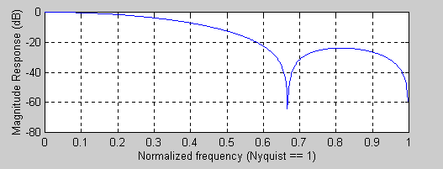
Figure 4. Four Element FIR Filter Frequency Response

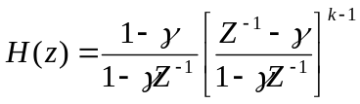Conventional filters use the Z transform to describe the filter transfer characteristic, where Z⁻¹ denoted a unit delay. There are a semi-infinite number of orthonormal functions for transform arithmetic. One such function is formed from Laguerre Polynomials. The mathematical expression for a k^{th} order Laguerre transfer response is:

The Laguerre Transform can be represented as a EMA low pass filter ( the first term), followed by a succession of all-pass elements instead of unit delays (the k-1 terms). All terms have exactly the same damping factor γ. We see these are all pass networks by examining the frequency response. When frequency is zero, the Z⁻¹ term has a value of 1, and therefore the element evaluates to (1- γ)/(1- γ) = 1. Similarly, when frequency is infinite, Z⁻¹ has a value of –1, and therefore the element evaluates to (-1- γ)/(1+ γ) = -1. The element has a unity gain at all frequencies between zero and infinity, and therefore is an all pass network. However, the phase from input to output shifts over the frequency range, causing the lag to be variable as a function of frequency. The degree to which the lag is variable depends upon the value of the damping factor γ. For example, the lag, or group delay, for γ = 0.6 and γ = 0.8 are shown in Figure 5.

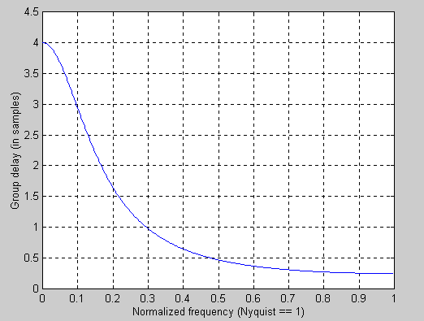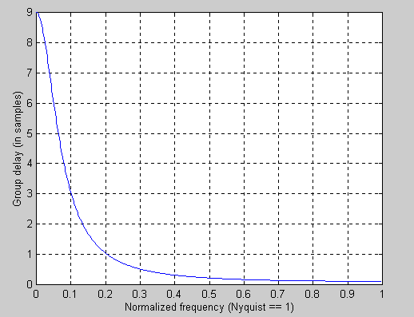
γ = 0.6 γ = 0.8
Figure 5. All Pass Network Lag is a Function of Frequency and Damping Factor

Therefore, we can make a filter using the Laguerre elements instead of the unit delay whose coefficients are also [1 2 2 1]/6 as with the FIR filter. The difference is that we have warped the time between the delay line times. The schematic of the Laguerre filter is shown in Figure 6.

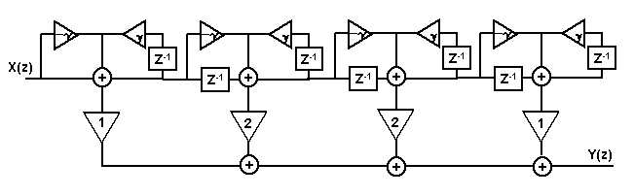
Figure 6. Laguerre Filter Schematic

The EasyLanguage code for a four element Laguerre Filter is given in Figure 7. L0 is the output of the first section, and is just an EMA. The following three sections are identical in their form. The four sections of the Laguerre delay line are summed exactly the same way as one would sum a linear delay line for a FIR filter. The Laguerre output is the “Filt” variable. An identical length FIR filter is also computed for comparison.

Inputs: Price((H+L)/2),
gamma(.8);

Vars: L0(0),
L1(0),
L2(0),
L3(0),
Filt(0)
FIR(0);

L0 = (1 - gamma)*Price + gamma*L0[1];
L1 = -gamma*L0 + L0[1] + gamma*L1[1];
L2 = -gamma*L1 + L1[1] + gamma*L2[1];
L3 = -gamma*L2 + L2[1] + gamma*L3[1];

Filt = (L0 + 2*L1 + 2*L2 + L3) / 6;
FIR = (Price + 2*Price[1] + 2*Price[2] + Price[3]) / 6;

Plot1(Filt, "Filt");
Plot2(FIR, "FIR");

Figure 7. Laguerre Filter EasyLanguage Code

The results of the Laguerre and FIR filter are shown in Figure 8. Remember both filters have identical lengths. The FIR filter (the green line) has a lag of only 1.5 bars and only moderately smoothes the price data. On the other hand, the Laguerre filter (the red line) is dramatically smoother and also has significant lag. You can decrease the smoothing and the lag by decreasing the damping factor. When the damping factor is reduced to zero, the Laguerre filter is identical to the FIR filter. This is a simple way to control the action of a moving average and still use only a few data samples in the calculation.
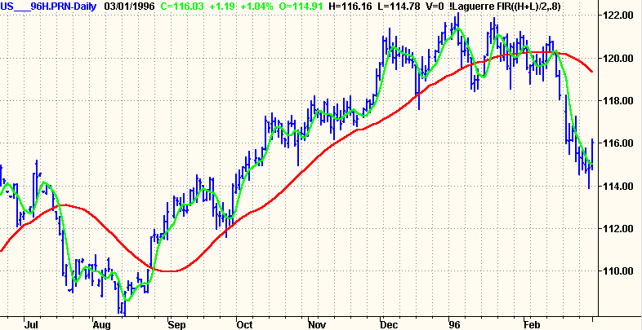
Figure 8. Four Element Laguerre Filter is Dramatically Smoother than a Conventional Four Element FIR Filter

The story does not end with conventional filters. As I am fond of saying “Truth and science always triumphs over ignorance and superstition”. If we can generate superior smoothing with very short filters, it follows that we should be able to create superior indicators using very short data lengths also. The use of shorter data lengths mean that we can make the indicators more responsive to changes in the price. As an example, the Laguerre RSI will be used.

Welles Wilder defined the RSI as
RSI = 100 - 100 / (1 + RS)
where RS = (Closes Up) / (Closes Down)
= CU / CD
RS is shorthand for Relative Strength. That is, CU is the sum of the difference in closing prices over the observation period where that difference is positive. Similarly, CD is the sum of the difference in closing prices over the observation period where that difference is negative, but the sum is expressed as a positive number. When we substitute CU/CD for RS and simplify the RSI equation, we get
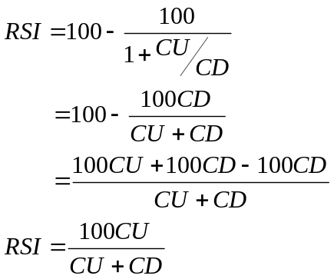
In other words, the RSI is the percentage of the sum of the delta closes up to the sum of all the delta closes over the observation period. In the EasyLanguage code of Figure 9, I have generated an RSI over Laguerre time rather than linear time, using only four data samples. In this case, I used a 0.5 damping factor, but you can adjust the damping factor that best suits your own data.

Inputs: gamma(.5);

Vars: L0(0),
L1(0),
L2(0),
L3(0),
CU(0),
CD(0),
RSI(0);

L0 = (1 – gamma)*Close + gamma*L0[1];
L1 = - gamma *L0 + L0[1] + gamma *L1[1];
L2 = - gamma *L1 + L1[1] + gamma *L2[1];
L3 = - gamma *L2 + L2[1] + gamma *L3[1];

CU = 0;
CD = 0;
If L0 >= L1 then CU = L0 - L1 Else CD = L1 - L0;
If L1 >= L2 then CU = CU + L1 - L2 Else CD = CD + L2 - L1;
If L2 >= L3 then CU = CU + L2 - L3 Else CD = CD + L3 - L2;

If CU + CD <> 0 then RSI = CU / (CU + CD);

Plot1(RSI, "RSI");
Plot2(.8);
Plot3(.2);

Figure 9. EasyLanguage Code for a Laguerre RSI Indicator

An example of the results of the 4 element Laguerre RSI are shown in Figure 10 as a subgraph below the price charts. The 20% and 80% signal levels are also plotted. Note that the excursions of the RSI are typically lock-to-lock and that the recovery is rapid at each major price reversal. A typical use of the Laguerre RSI is to buy after the line crosses back over the 20% level and sell after the price crosses back down over the 80% level. Of course, just as with the conventional RSI, more elaborate trading rules can be created.

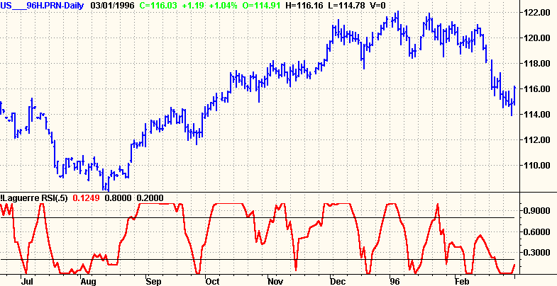
Figure 10. A Laguerre RSI Reacts Rapidly to Price Changes

More elaborate rules are not necessarily required because the Laguerre RSI system was found to be the top performer of all systems registered at www.wellinvested.com with 118.3% annualized return on AKSYS Ltd. WellInvested.com is a website where a wide variety of automatic trading systems are applied across most listed stocks and futures. Several searches are interesting. The highest performing systems can be found for a given symbol or the highest performing symbols can be found for a given system, for example. It turns out that the two Laguerre systems were the highest performers on the popular DIA contract for calendar 2002, as shown in Figure 11.

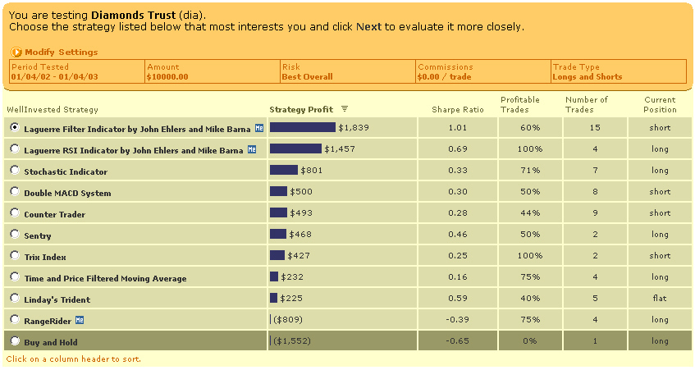
Figure 11. Screen Capture from www.wellinvested.com, Showing the Laguerre Trading Systems were the top performers on the popular DIA contract in 2002

CONCLUSIONS

The Laguerre Transform provides a time warp such that the low frequency components of price are delayed much more than the high frequency components. This feature enables smoothing filters to be created using only a small amount of data. Similarly, indicators using only a few data samples can also be created using the time warp. Since these indicators use only a few data samples, they can be made to be much more responsive to recent price data. More responsiveness translates to faster reaction times in placing the trades and, consequently, improved profitability due to the reduction in signal lag.

